Lab 2 - Exploration of Vision Impairments

Step 1


Step 2
🔵 Deuteranopia (Red–Green color blindness)
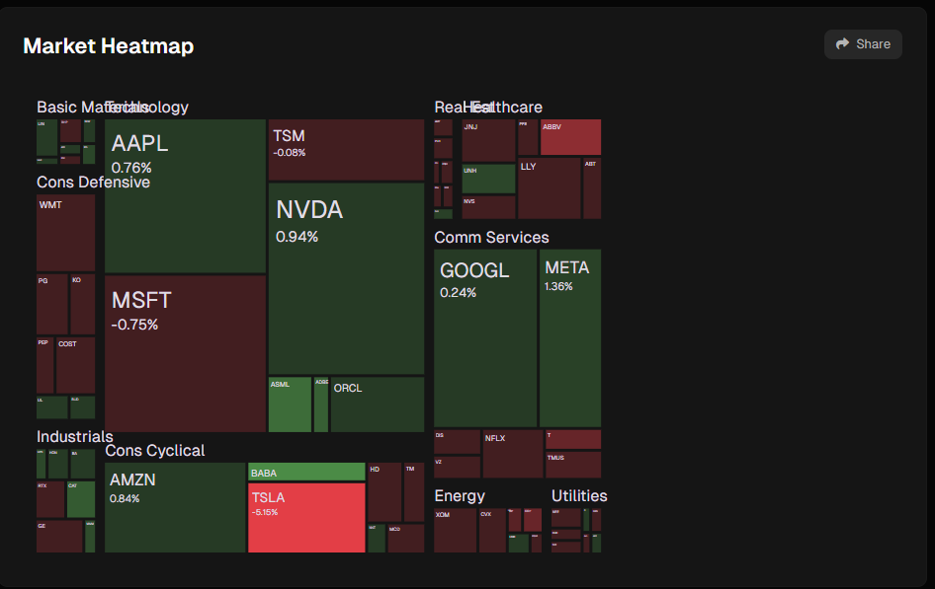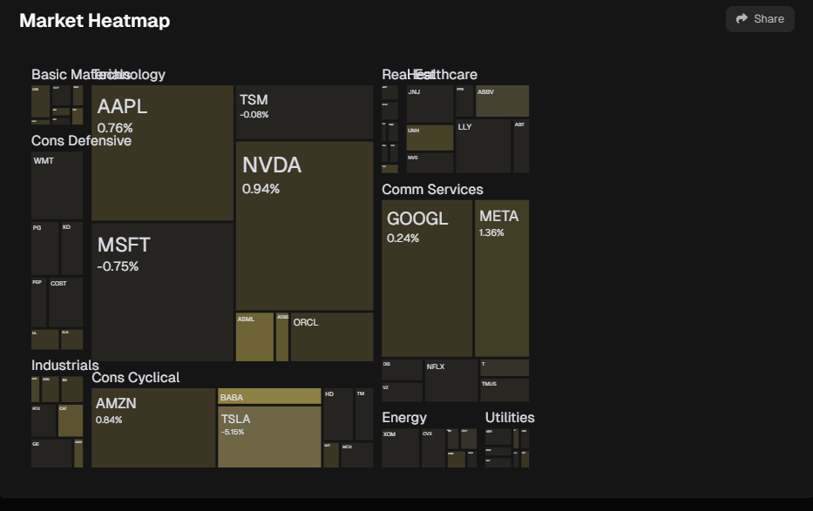
What looks different compared to full-color view?
The different colors scheme like - green becomes yellow and red becomes black

Which information is harder (or impossible) to get at a glance?
That’s really hard to see red squares you can even skip them if you will scroll fast

Which features are still usable?
Still usable only green(yellow) squares, text and numbers information

Where is color alone doing all the communication?
The yellow boxes still show enough information

Evaluate the Usability

How quickly can you tell which stocks are “up” vs “down”?
By looking on yellow boxes(green) they are still showing which one are growing the black ones are going down, but it’s very hard so tell how strong they are going down because of black color

Imagine you had to decide investment at a glance: how does the experience compare to someone with normal vision?
That’s actually really hard to see fast. You have to check numbers before you go (anyway you will do that with normal vision but why do you need red and green then?) because that’s really hard to see which one of black boxes go dipper down
Redesign Challenge

Suggest at least two design changes that would make this heatmap more accessible without losing clarity for color‑sighted users.
Add color blind mode or make it more accessible

I think they can change the color red(black) color to purple that will make black boxes look like blue boxes and that will be much easier to see.

🔍 Low Acuity (Blurriness, like cataracts)
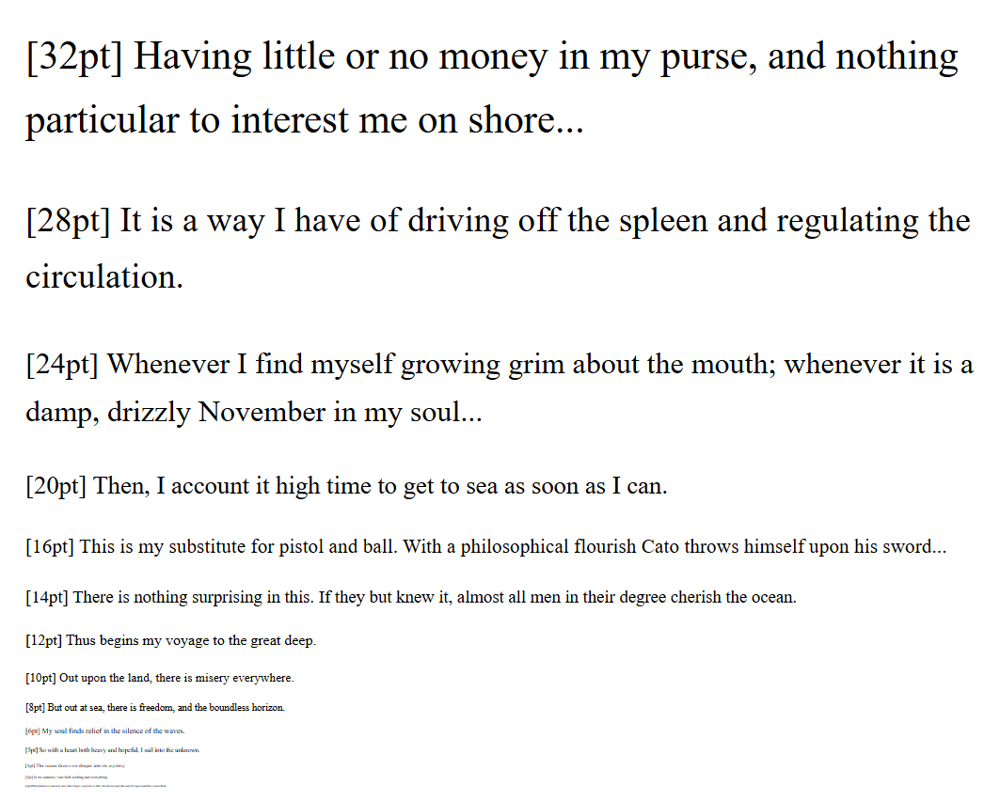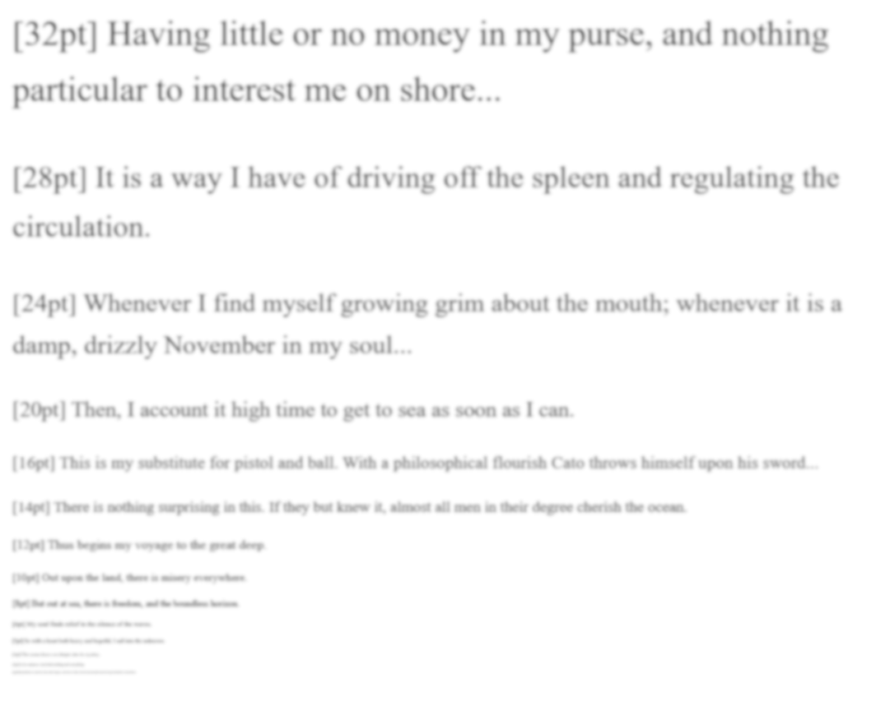
Which is the smallest font size readable under normal conditions?
For me font sizes remain readable from the [36]px to [5]px

Which becomes illegible under blur emulation?
For me font sizes remain readable from the [36]px to [12]px

Which font was most difficult, and why?
Condiment - was the most difficult to read with other fonts I could see up to 5px but with that font I can read only 8px. But with blurred vision I could read up to 12px but with Condiment I hardly can read 20px

What font properties helped readability?
Courier New - With that font that much easier to read smaller text especially when you have blurred vision

⚪ Low Contrast (Glaucoma-like) — Dickens Contrast Page
· Which paragraph is comfortably readable (normal vision)?
1st paragraph the most readable because of black font and white background
· Which paragraph first feels difficult?
3rd paragraph start being a bit difficult to read
· Under low-contrast emulation, which becomes unreadable first?
3rd one completely unreadable
· Did your readability threshold shift?
Yes
· How did reduced contrast affect skimming vs reading carefully?
If you are skimming you can’t read 2nd paragraph but if you are reading careful you can read 2nd paragraph
· Do borders or highlights help when contrast is poor?
Yes, back ground helps a lot especially black and navy if you use them they can help to read all the lines when contrast is poor
· How did yellow highlighting behave under blur vs low contrast?
When blurred vision you can read (bit difficult because of blur) all 6 paragraphs, with low contrast it changes nothing still you can read only 2 paragraphs

Pick your top 2 issues across all impairments:
1. Most surprising challenge noticed:
For me most surprised was low contrast challenge, I couldn't imagine that people can have that kind of problems
2. Which impairment made the site hardest to use (& why):
The low contrast can make website completely unreadable

